THE NEW BOTTOM LINE WILL TAKE YOU BY SURPRISE

Anthony H. Catanach Jr. and J. Edward Ketz
Grumpy Old Accountants, April 2012

Guest Column: Roman L. Weil (University of Chicago)

The bottom line has changed and you may not know it.

Have you ever heard of Other Comprehensive Income (OCI)? [25 percent of my audiences of managers, corporate lawyers and directors have.] Have you ever used OCI in making any decision? [About 20 percent of those who’ve heard of it have used it; that is about 5 percent of my audiences have ever used OCI to make a decision.]

Why do you care? Because starting now, the income statements you’ll see will have a new bottom line. It will no longer be net income, but will be Comprehensive Income, which is conventional net income plus OCI.

See the top half of the accompanying exhibit, where net income (or earnings) is in the middle and Comprehensive Income is at the bottom. You might see a two statement approach, as in the bottom half of the exhibit.

What to do about the new OCI data? From my perspective, analysts need to understand that, just as with extraordinary items and discontinued operations, these items do not attract a price-earnings (“p.e.”) multiple for valuation different from 1.00. Mindless use of conventional p.e. ratios will lead to nonsensical results.

If you think you can ignore OCI, then think about your reaction to the recent information that cities are going insolvent over their inability to pay pension costs. If municipal accounting had an equivalent of OCI and its balance sheet Accumulated Other Comprehensive Income, none of us would have been so taken by surprise. Accumulated Other Comprehensive Income is to OCI the way the Retained Earnings account on the balance sheet is to Net Income – Dividends.

ONE-STATEMENT APPROACH
Statement of Net Income and Comprehensive Income
Revenues . . . . . . . . . . . . . . . . . . . . . . . . . . . . . . . . . . . . . . . . . . . . . . . . . . . . . . . . . . . . . . . . . |  | $100,000
Expenses . . . . . . . . . . . . . . . . . . . . . . . . . . . . . . . . . . . . . . . . . . . . . . . . . . . . . . . . . . . . . . . . . |  | (25,000)
Gain on Sale of Securities . . . . . . . . . . . . . . . . . . . . . . . . . . . . . . . . . . . . . . . . . . . . . . . . . . . . . . |  | 2,000
Other Gains and Losses . . . . . . . . . . . . . . . . . . . . . . . . . . . . . . . . . . . . . . . . . . . . . . . . . . . . . . . . |  | 8,000
Earnings from Continuing Operations before Income Tax . . . . . . . . . . . . . . . . . . . . . . . . . . . . . . . . |  | $ 85,000
Income Tax Expense . . . . . . . . . . . . . . . . . . . . . . . . . . . . . . . . . . . . . . . . . . . . . . . . . . . . . . . . . . |  | (21,250)
Earnings before Discontinued Operations and Extraordinary Items . . . . . . . . . . . . . . . . . . . . . . . . . |  | $ 63,750
Discontinued Operations, Net of Tax . . . . . . . . . . . . . . . . . . . . . . . . . . . . . . . . . . . . . . . . . . . . . . . |  | 30,000
Extraordinary Items, Net of Tax . . . . . . . . . . . . . . . . . . . . . . . . . . . . . . . . . . . . . . . . . . . . . . . . . . |  | (30,500)
Net Income (or, as preferred by the FASB, Earnings) . . . . . . . . . . . . . . . . . . . . . . . . . . . . . . . . . . Other Comprehensive Income, Net of Tax:  Foreign Currency Translation Adjustments . . . . . . . . . . . . . . . . . . . . . . . . . . . . . . . . . . . . . . . . . . . |  | $ 63,250  7,000
Unrealized Gains and Losses on Securities:  Unrealized Holding Gains Arising during Period . . . . . . . . . . . . . . . . . . . . . . . . . . . . . . . . . . . . . . | $13,000
Less: Reclassification Adjustment for Gain Included in Net Income (Earnings) . . . . . . . . . . . . . . . . . | (1,500) | 11,500
Minimum Pension Liability Adjustment . . . . . . . . . . . . . . . . . . . . . . . . . . . . . . . . . . . . . . . . . . . . . |  | (2,500)
Other Comprehensive Income (Loss) . . . . . . . . . . . . . . . . . . . . . . . . . . . . . . . . . . . . . . . . . . . . . . . |  | $ 16,000
Comprehensive Income (Loss) . . . . . . . . . . . . . . . . . . . . . . . . . . . . . . . . . . . . . . . . . . . . . . . . . |  | $ 79,250

TWO-STATEMENT APPROACH
Statement of Net Income
Revenues . . . . . . . . . . . . . . . . . . . . . . . . . . . . . . . . . . . . . . . . . . . . . . . . . . . . . . . . . . . . . . . . . | $100,000
Expenses . . . . . . . . . . . . . . . . . . . . . . . . . . . . . . . . . . . . . . . . . . . . . . . . . . . . . . . . . . . . . . . . . | (25,000)
Gain on Sale of Securities . . . . . . . . . . . . . . . . . . . . . . . . . . . . . . . . . . . . . . . . . . . . . . . . . . . . . . | 2,000
Other Gains and Losses . . . . . . . . . . . . . . . . . . . . . . . . . . . . . . . . . . . . . . . . . . . . . . . . . . . . . . . . | 8,000
Earnings from Continuing Operations before Income Tax . . . . . . . . . . . . . . . . . . . . . . . . . . . . . . . . | $ 85,000
Income Tax Expense . . . . . . . . . . . . . . . . . . . . . . . . . . . . . . . . . . . . . . . . . . . . . . . . . . . . . . . . . . | (21,250)
Earnings before Discontinued Operations and Extraordinary Items . . . . . . . . . . . . . . . . . . . . . . . . . | $ 63,750
Discontinued Operations, Net of Tax . . . . . . . . . . . . . . . . . . . . . . . . . . . . . . . . . . . . . . . . . . . . . . . | 30,000
Extraordinary Items, Net of Tax . . . . . . . . . . . . . . . . . . . . . . . . . . . . . . . . . . . . . . . . . . . . . . . . . . | (30,500)
Net Income (or, as preferred by the FASB, Earnings) . . . . . . . . . . . . . . . . . . . . . . . . . . . . . . . . . . | $ 63,250
Statement of Comprehensive Income
Net Income (or, as preferred by the FASB, Earnings) . . . . . . . . . . . . . . . . . . . . . . . . . . . . . . . . . . $ 63,250
Other Comprehensive Income, Net of Tax:
Foreign Currency Translation Adjustments . . . . . . . . . . . . . . . . . . . . . . . . . . . . . . . . . . . . . . . . . . . 7,000
Unrealized Gains and Losses on Securities:
Unrealized Holding Gains Arising during Period . . . . . . . . . . . . . . . . . . . . . . . . . . . . . . . . . . . . . . | $13,000
Less: Reclassification Adjustment for Gain Included in Net Income (Earnings) . . . . . . . . . . . . . . . . . | (1,500) | 11,500
Minimum Pension Liability Adjustment . . . . . . . . . . . . . . . . . . . . . . . . . . . . . . . . . . . . . . . . . . . . . |  | (2,500)
Other Comprehensive Income (Loss) . . . . . . . . . . . . . . . . . . . . . . . . . . . . . . . . . . . . . . . . . . . . . . . |  | $ 16,000
Comprehensive Income (Loss) . . . . . . . . . . . . . . . . . . . . . . . . . . . . . . . . . . . . . . . . . . . . . . . . . |  | $ 79,250

How much time do you suppose will pass before the eye learns to focus on the number on the bottom, not the number in the middle? I’m guessing less than three years.

Here’s the story. Managers like to control reported income. For two decades or so, the market rewarded managers who produce steadily growing income. The poster boy of this was Jack Welch at GE, who received praise and pay for reporting steadily growing
quarter-over-quarter income for more than a decade.

During the last thirty years, accounting standard setters have realized that several factors, over which management has little control, can change a company’s reported perform- ance. Consider, for example gains and losses on investments in a company’s funds that support defined benefit pension plan. Or, its investments in securities it holds for pur- poses other than trading. Or, foreign exchange gains and losses from doing business in multiple currencies without being able to put on completely effective hedges. Account- ing refers to some items of this kind as components of “other comprehensive income.”

Accountants know that such factors change wealth, but management cannot easily control them. Over time, managements have successfully pressured accounting standard setters
to keep such gains and losses, as they occur, out of the conventional income statement. Still, accounting standard setters have resolved that financial statement readers be alerted to these changes in shareholder wealth. So for about 20 years, the standard setters have required that companies report on the components of OCI, then show the sum of conven- tional net income plus OCI as (Total) Comprehensive Income. But the reporting has
been opaque.

Until recently, the standard setters allowed companies to present the components of OCI in such an obscure way that few noticed it or fewer still comprehended it. My favorite form of obfuscation was the format GE used until its 2008 statements, released in 2009, when it switched to a less confusing format, still not comprehensible to most readers, but better than before.

Starting now (in December 2011) companies must show OCI in parallel with conventional net income and the total of these two, Comprehensive Income, at the bottom.

Most companies will likely not call it Comprehensive Income, but use an alternative title allowed by the FASB, Total Changes in Shareholder Wealth from Transactions Other than With Owners, and will likely print the details of OCI on a page separate from, but following, the presentation of Earnings.

The two presentation formats used by the General Electric Company in recent years provide alternative formats that many companies will use. The bottom statement will be called Statement of Comprehensive Income or Statement of Changes in Shareholder Wealth from Transactions Other than With Owners.

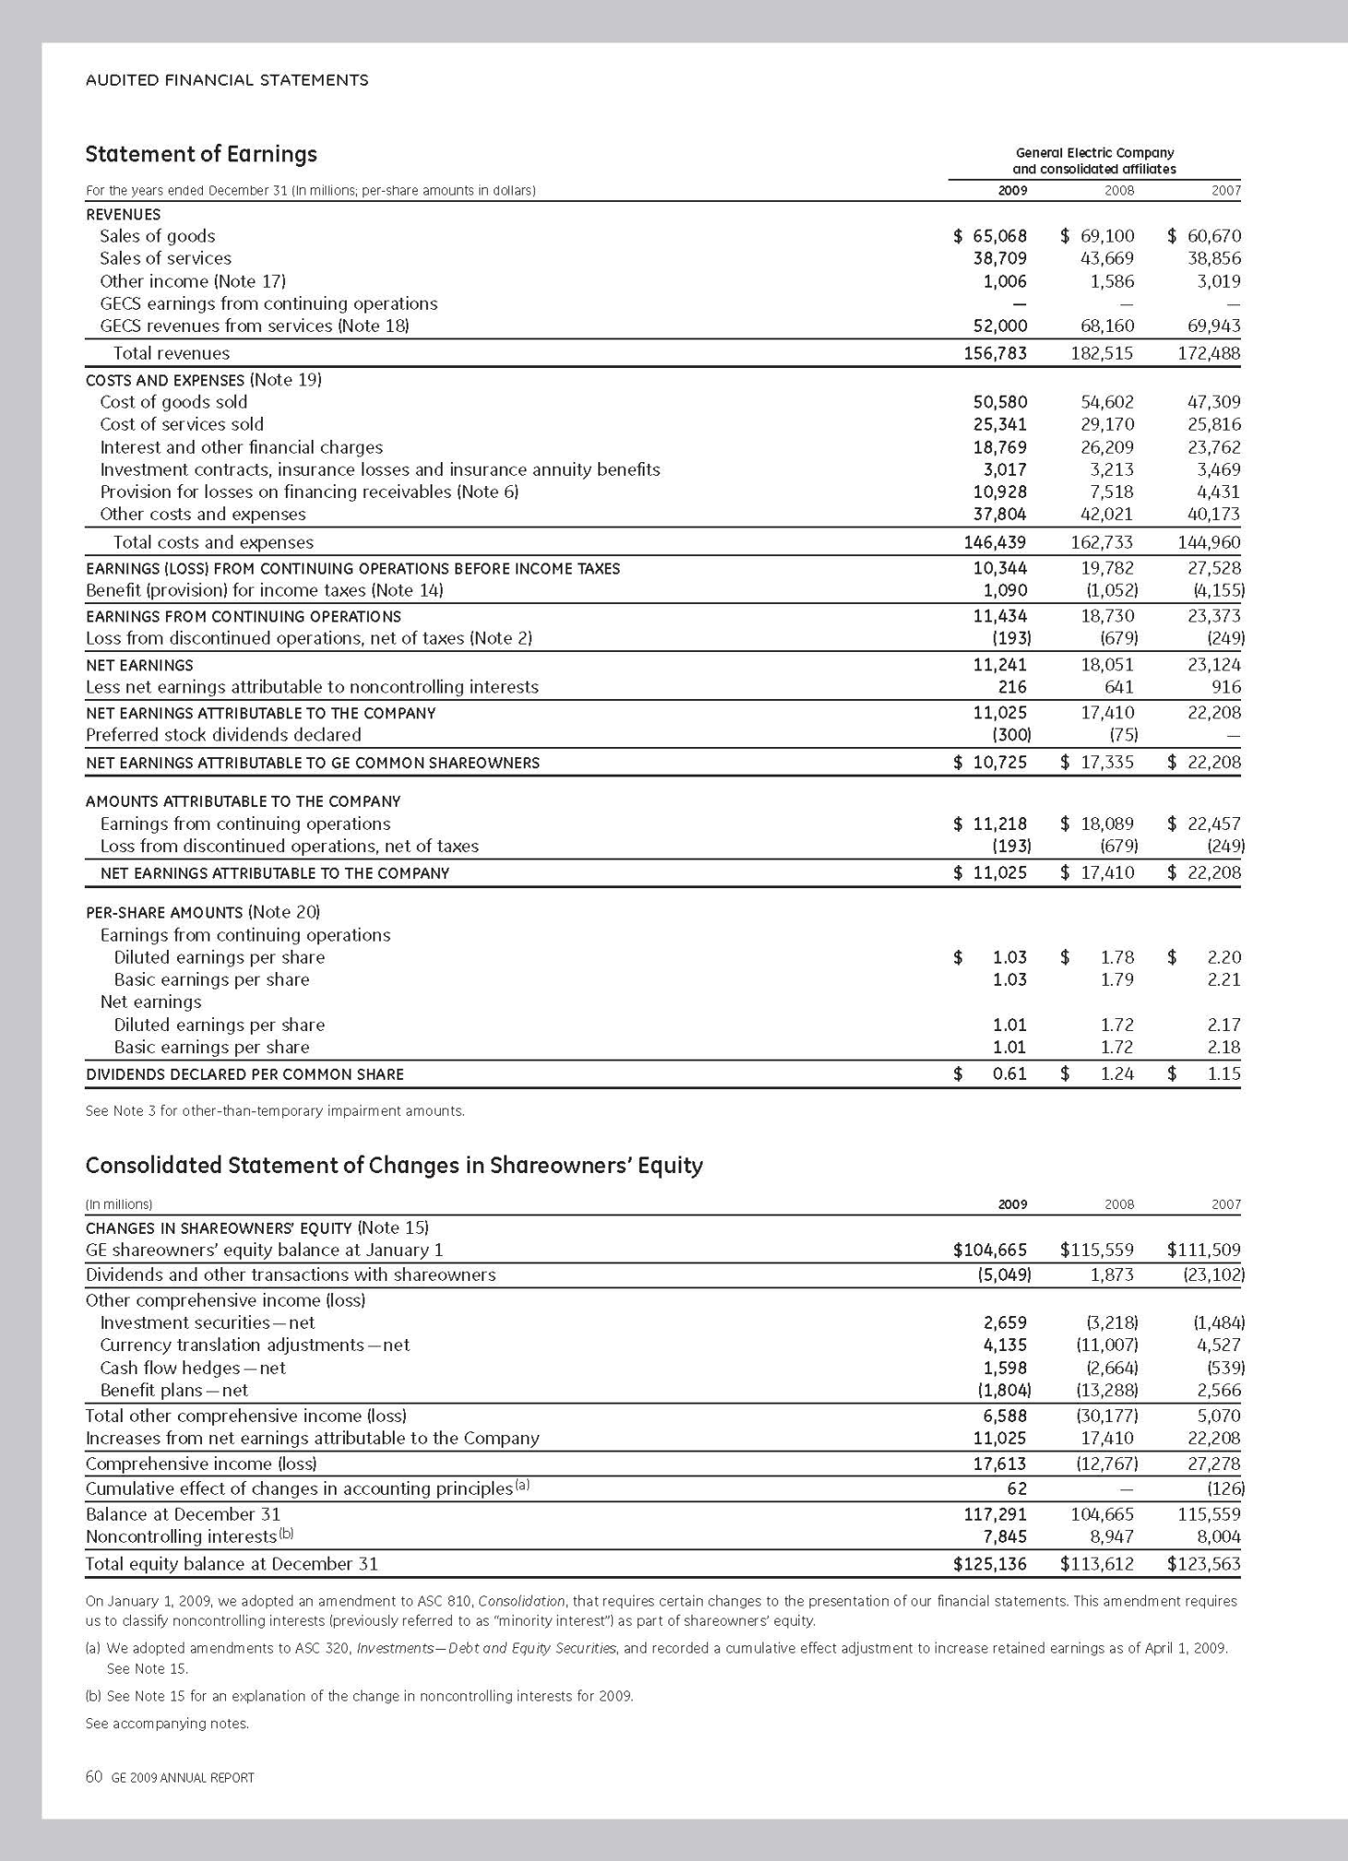

Statement of Earnings

General Electric Company and consolidated affiliates

For the years ended December 31 (In millions; per-share amounts in dollars) | 2007 | 2006 | 2005
REVENUES
Sales of goods | $ 60,670 | $ 55,181 | $ 50,727
Sales of services | 38,856 | 36,329 | 32,839
Other income (note 3)  GECS earnings from continuing operations  GECS revenues from services (note 4) | 3,019  —  70,193 | 2,154  —  58,179 | 1,673  —  51,341
Total revenues | 172,738 | 151,843 | 136,580
COSTS AND EXPENSES (note 5) Cost of goods sold | 47,309 | 43,279 | 39,169
Cost of services sold | 25,816 | 23,494 | 20,615
Interest and other financial charges | 23,787 | 18,896 | 14,811
Investment contracts, insurance losses and insurance annuity benefits | 3,469 | 3,213 | 3,374
Provision for losses on financing receivables (note 13) | 4,546 | 3,130 | 3,239
Other costs and expenses | 40,297 | 35,639 | 33,278
Minority interest in net earnings of consolidated affiliates | 916 | 862 | 916
Total costs and expenses | 146,140 | 128,513 | 115,402
EARNINGS FROM CONTINUING OPERATIONS BEFORE INCOME TAXES | 26,598 | 23,330 | 21,178
Provision for income taxes (note 7) | (4,130) | (3,950) | (3,824)
EARNINGS FROM CONTINUING OPERATIONS | 22,468 | 19,380 | 17,354
Earnings (loss) from discontinued operations, net of taxes (note 2) | (260) | 1,362 | (634)
NET EARNINGS | $ 22,208 | $ 20,742 | $ 16,720
Per-share amounts (note 8)
Per-share amounts — earnings from continuing operations
Diluted earnings per share | $ 2.20 | $ 1.86 | $ 1.64
Basic earnings per share | 2.21 | 1.87 | 1.64
Per-share amounts — net earnings
Diluted earnings per share | 2.17 | 2.00 | 1.57
Basic earnings per share | 2.18 | 2.00 | 1.58
DIVIDENDS DECLARED PER SHARE | $ 1.15 | $ 1.03 | $ 0.91
Consolidated Statement of Changes in Shareowners’ Equity
(In millions) | 2007 | 2006 | 2005
CHANGES IN SHAREOWNERS’ EQUITY (note 22) Balance at January 1 | $111,509 | $108,633 | $110,181
Dividends and other transactions with shareowners | (23,102) | (17,983) | (13,249)
Changes other than transactions with shareowners  Investment securities—net | (1,484) | (223) | (437)
Currency translation adjustments — net | 4,527 | 3,649 | (4,318)
Cash flow hedges — net | (539) | 223 | (47)
Benefit plans — net | 2,566 | 287 | (217)
Total changes other than earnings | 5,070 | 3,936 | (5,019)
Increases attributable to net earnings | 22,208 | 20,742 | 16,720
Total changes other than transactions with shareowners | 27,278 | 24,678 | 11,701
Cumulative effect of changes in accounting principles(a) | (126) | (3,819) | —
Balance at December 31 | $115,559 | $111,509 | $108,633
(a) The effect of the 2006 accounting change was previously included in the caption “Benefit plans — net .”
See accompanying notes.

64 ge 2007 annual report

You will not be able to avoid seeing OCI and Comprehensive Income, but you may not see it called that. This will change your life, whether you be manager deciding on transactions with income in mind, or analyst deciding what components of income are recurring, or corporate lawyer writing bond covenants based on accounting data, or labor negotiator deciding how much the company is earning, or legislator/regulator deciding what one can tax.

Now, is the time to start learning about it.

Roman L. Weil is V. Duane Rath Professor Emeritus at the Chicago Booth School of
Business.

This essay reflects the opinion of the authors and not necessarily the opinions of The Pennsylvania State University, The American College, or Villanova University.

